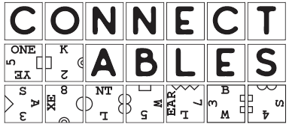
(August 13, 2024)
Connectables is an engaging, tile-laying game where players connect patterns, words, and numbers to outsmart their opponents. Each tile features a unique combination of a number, shape, and letters on its edges. The goal is to strategically place tiles to form connections along the edges, creating a dynamic and ever-changing game board. The first player to successfully place all their tiles wins the round. For one or more players, aged 5+

COMPONENTS:
- 77 Wooden Tiles with numbers, letters and symbols along four edges. Black and white so no color blindness issues.
- 20 Target Tokens
- Box or Tin.

SETUP:
- Shuffle the tiles and tokens.
- Grab one tile and place it between the players.
- Give each player five tiles face up
- Give each player at least three target tokens.

GAME PLAY:
Players take turns placing one tile at a time. Tiles must be placed so that at least one edge matches an adjacent tile’s edge in one of three ways:
- the two adjacent numbers add up to 10 or target number.
- the adjacent letters spell a word (2-5 letters).
- the adjacent halves of patterns form a complete pattern.

To connect two or more edges, all connections must be valid.

If a tile cannot be placed, draw an additional tile and end your turn.

You may stack tiles as long as all edge connections are valid.

Target Tokens:
You must dispense all of your target tokens as follows:
- AZ: when you form a word
- 5-9: as you form a sum adding up to the number shown.
If you have just target token(s) but no tiles, draw another tile.
Play until one player has eliminated all their tiles and target tokens. That player is the winner of the round. However, the remaining players get one more chance to make a connection.

Play at least two rounds to determine the overall winner.

Fair Play:
If you are a family playing with younger children, consider giving the youngest players just the numbered target tokens. This allows them to concentrate on patterns and numbers instead of words.

SOLO MODE: Grab 15 or more tiles and five target tokens and connect them all.

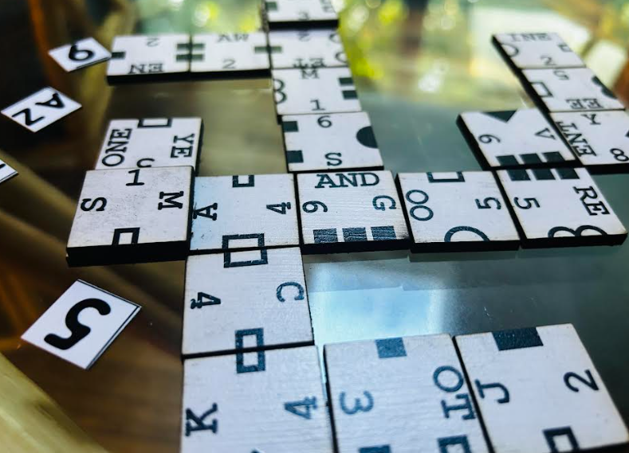
SEND US A PHOTO OR VIDEO
Please post a photo or video of your family playing the game. Tag #connectables and @brainy.games on Instagram. We’ll mail you a free memory game as thank you gift.

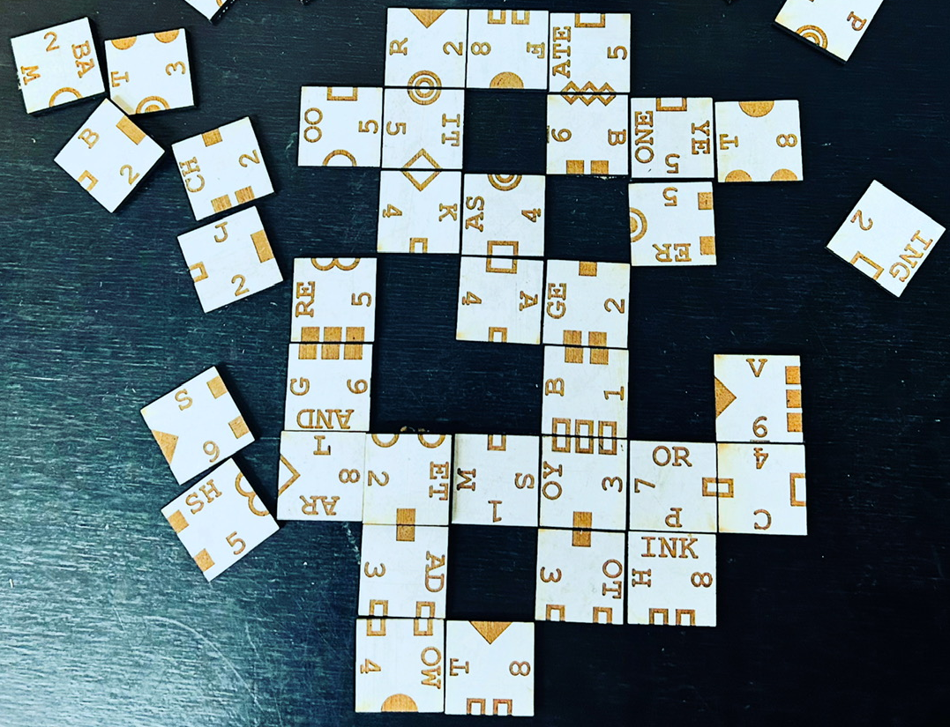
Copyright © 2024 Knowledge Probe Inc.
www.Brainy.games
(August 12, 2024)
Connectables is an engaging, tile-laying game where players connect patterns, words, and numbers to outsmart their opponents. Each tile features a unique combination of a number, shape, and letters on its edges. The goal is to strategically place tiles to form connections along the edges, creating a dynamic and ever-changing game board. The first player to successfully place all their tiles wins the round. For one or more players, aged 5+

COMPONENTS:
- 77 Wooden Tiles with numbers, letters and symbols along four edges. Black and white so no color blindness issues.
- 20 Target Tokens
- Box or Tin.

SETUP:
- Shuffle the tiles and tokens.
- Grab one tile and place it between the players.
- Give each player five tiles face up
- Give each player at least three target tokens.

GAME PLAY:
Players take turns placing one tile at a time. Tiles must be placed so that at least one edge matches an adjacent tile’s edge in one of three ways:
- the two adjacent numbers add up to 10 or target number.
- the adjacent letters spell a word (2-5 letters).
- the adjacent halves of patterns form a complete pattern.

To connect two or more edges, all connections must be valid.

If a tile cannot be placed, draw an additional tile and end your turn.

You may stack tiles as long as all edge connections are valid.

Target Tokens:
You must dispense all of your target tokens as follows:
- AZ: when you form a word
- 5-9: as you form a sum adding up to the number shown.

Play until one player has eliminated all their tiles and target tokens. That player is the winner of the round. However, the remaining players get one more chance to make a connection.

Play at least two rounds to determine the overall winner.

Fair Play:
If you are a family playing with younger children, give the youngest players just the number target tokens. This allows them to concentrate on patterns and numbers instead of words.

SOLO MODE: Grab 15 or more tiles and five target tokens and connect them all.

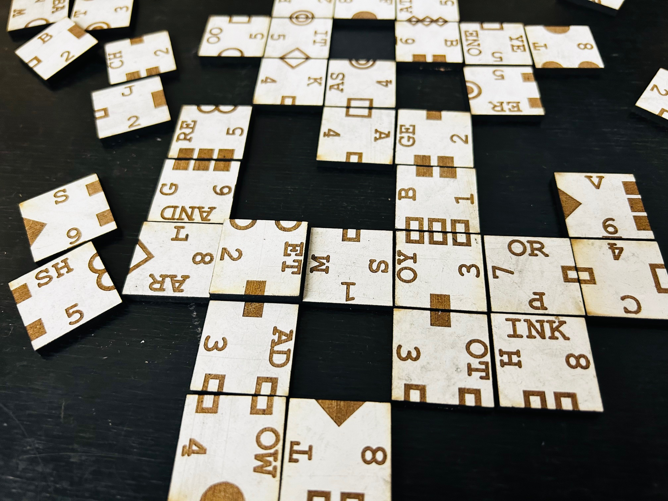
SEND US A PHOTO OR VIDEO
Please post a photo or video of your family playing the game. Tag #connectables and @brainy.games on Instagram. We’ll mail you a free memory game as thank you gift.

Copyright © 2024 Knowledge Probe Inc.
www.Brainy.games

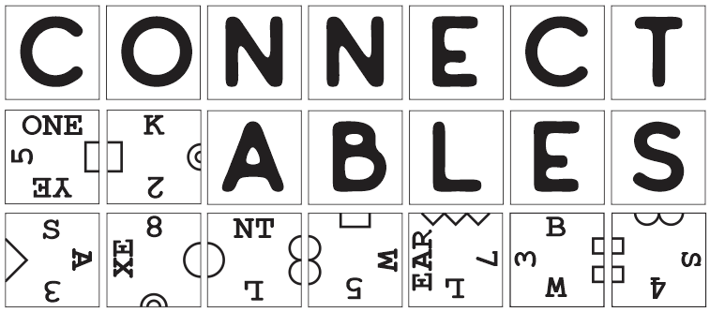

A fast-paced, engaging and strategic tile-laying game where players connect patterns, words and numbers to outsmart their opponents.
It's easy to learn but offers enough depth to keep players coming back for more.
Includes an addictive solo mode. 77 wooden tiles.

Strategic Depth: Players must think ahead and plan their moves to maximize connections and block opponents.
Dynamic Gameplay: The game board evolves with each tile placement, creating new opportunities and challenges.
Educational Value: Promotes pattern recognition, word formation, and numerical skills, making it a fun and educational experience for players of all ages.
Replayability: With a variety of tiles and endless possible connections, no two games are ever the same.
Target Audience: Perfect for families, casual gamers and party games.
