SkyLinks
SkyLinks is a structural word game with a bit of math and pattern recognition thrown in. Six ways to play.

Stack and balance magnetic cubes to quickly build words, solve simple math equations or match patterns. The cubes have letters, bigrams, numbers and symbols. You can strategize a variety of endless connections in all directions.
SkyLinks uplifts game play to a whole new level!
For ages 5 and up.

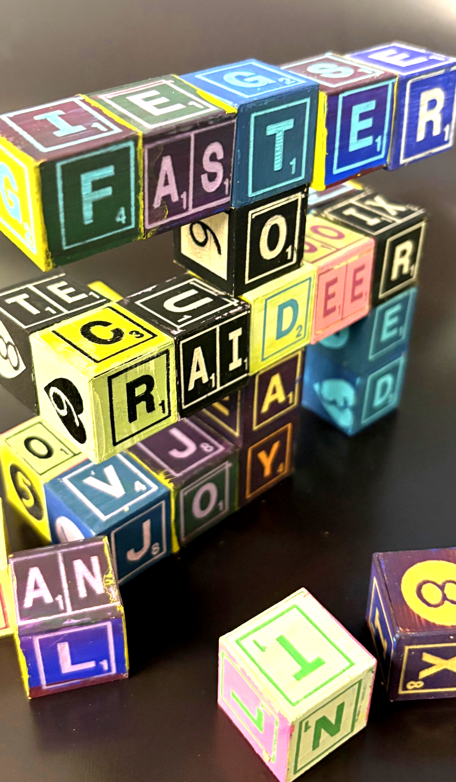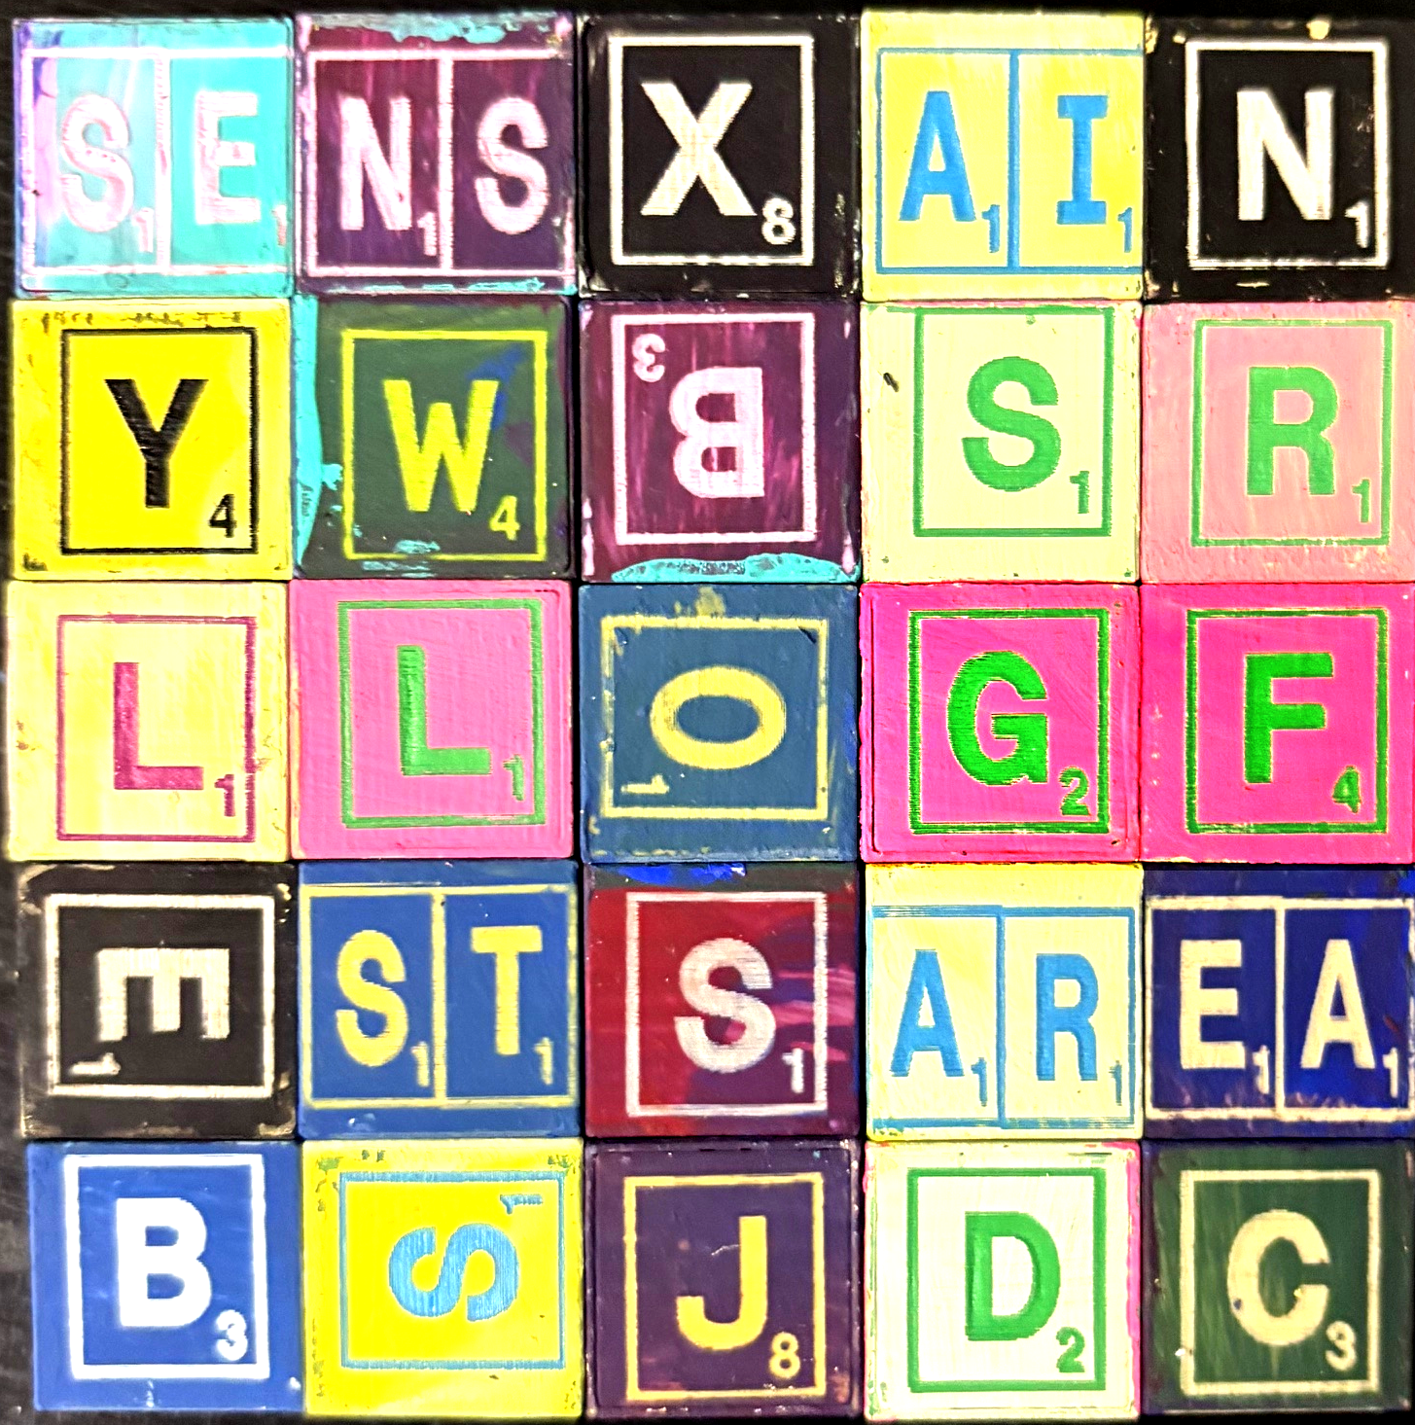

SIX WAYS TO PLAY
VERTICAL TOWER GAME: (Like 3D Scrabble®!)
Setup - Place a random cube between players as the base of a tower. This cube can be examined and rotated at first. Give each player two cubes. Choose to play cooperatively or competitively.
Game Play - Simultaneously attach one or more cubes to an existing cube to …
Form a Word or Sum to 10 or Match Symbols
  6 points | 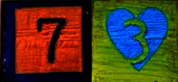  10 points |   7 points
Connect letters to an existing letter in any orientation as long as the letters are adjacent. Spanning through an inside corner is also allowed to make a connection.
Scoring:
Words: Total of the letters’ points.
Sum to Ten: 10 points.
Symbols: Sum of numbers of matching symbols.

MULTI-PLAYER GAME: (Build Your Best Words)
Setup – Each player starts with four cubes. Grab a pen and paper for scoring.
Game Play - Twist and align your cubes to form the highest-scoring word possible within one or two minutes. Score your word. Pass two cubes to the player on your left to shift the game dynamics - the cubes must be those you used with the highest and lowest values. Repeat five rounds.
Best Total Score Wins!

SOLO GAME: (Build Your Best Words)
Use all 25 cubes to construct at least four words, challenging yourself to find the best-scoring combinations!

CROSSWORDS GAME: (Horizontal Tabletop Mode.)
Setup - Place one random cube in the middle of the table. This cube can be examined and rotated. Give each player an equal number of cubes. Choose to play cooperatively or competitively.
Game Play - Take turns adding cubes to make intersecting crosswords in any direction. Only the top cubes are used.
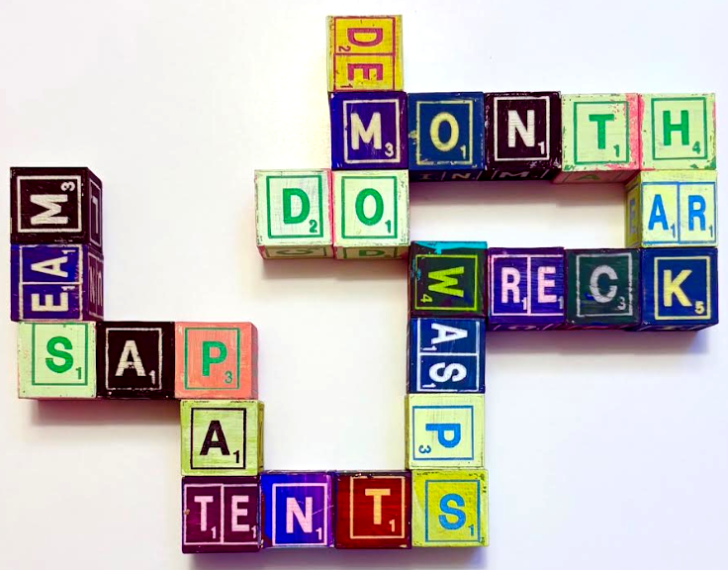

DAILY FRIDGE GAMES: (A Daily Family Challenge!)
Stick the cubes on your fridge (steel) door to compete with your family leaving new words each time you visit the fridge.

WORD SEARCH: (Find All Hidden Words)
Setup – Arrange cubes in a 5x5 square. Grab a pen and paper for scoring.
Game Play – All players simultaneously call out words from adjacent letters and score their values. Letters can zig-zag and weave in all directions including diagonals, but the same letter can only be used once. When no more words can be found, rearrange the cubes and play again. Play until someone reaches 100 points for the win.
Word Search Examples
BEST JARS AREA CARDS  RAINS GRAINS BOGS  BELLS LOGS STOW LOGS | 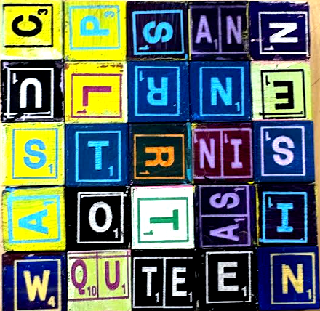  CUPS QUOTE QUOTAS  TEE TEAS TEEN RAN TOTE  SAW SIN SINE TOW ROW

Copyright © 2025 Knowledge Probe Inc (dba Brainy.games)

